Student support sheet

Picture this

Page 1/1

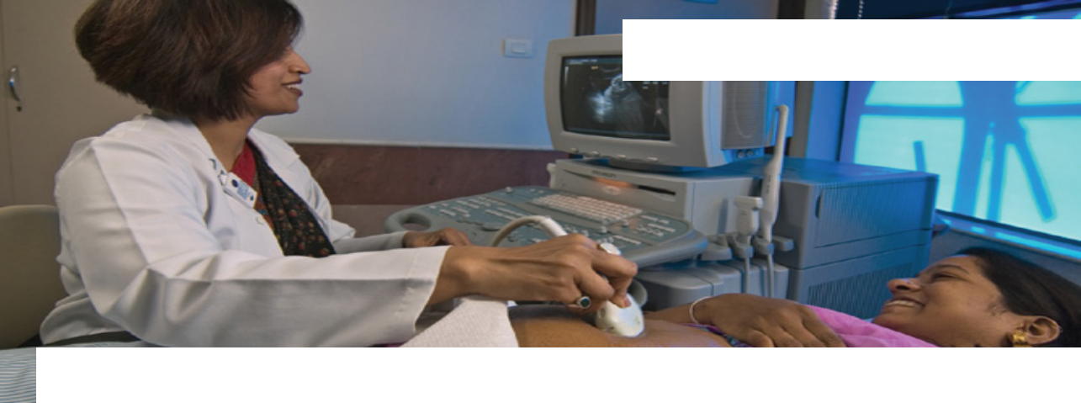
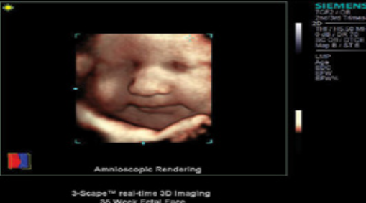
9 How ultrasound forms images of the inside of the body

A radiographer uses ultrasound technology on a pregnant patient

3D image of a foetus

Every time the waves
reach something different, such as bone, or an organ such as the heart, more of them are reflected back. The machine uses these reflected waves to build
up an image on the screen.
The ultrasound machine produces high frequency sound – much too high for anyone to hear. The frequency is in millions of waves per second, so it’s measured in megahertz (MHz). These are directed into your body using a probe and travel through it until they reach the edge of something different. For example, if they’re travelling through hard tissue and reach soft tissue, or through soft tissue and reach some fluid.

Some of the waves will continue to reach another boundary and more waves will be reflected from that. Therefore the machine detects the edges of tissues and organs and displays them on a screen

When the ultrasound waves travel back down
through the body, some of these waves are reflected. These are picked up by the probe. The machine
knows how fast the waves travel through the body (around 1500 m/s) and has recorded the time interval between transmission and reception. From these it can work out the distance travelled and therefore how far beneath the skin the boundary is.

By angling the probe, the direction of the waves can be changed and an image of a different part of the body formed.

Scheme of work 9 - episodes 5 and 6

