Medicine Maker
RESISTANCE IS FUTILE?
AIM OF ACTIVITY
To consider how antibiotics work and explore antibiotic-resistant bacteria.
ABOUT THE ACTIVITY
- Antibiotics are medicines used to prevent and treat bacterial infections. Sometimes, bacteria can change to be able to survive an antibiotic attack. One common cause for this is people using antibiotics when they have a viral infection. It can also happen if you don’t take all of the antibiotics a doctor prescribes – you’ll kill the weaker bacteria but the strongest will survive and re-grow! When this happens, we talk about the bacteria as being antibiotic resistant. Only it is resistant – not the people or animals they infect.

- If these bacteria infect humans or animals, the infections they cause are harder to treat than those caused by non-resistant bacteria. Antibiotic-resistant bacteria are one of the biggest challenges facing medicine in the 21st century, so always do what your doctor tells you with medicines.
The objective is to show that some bacteria are not affected by the antibiotics.

WHAT YOU’LL NEED
- Marshmallows to be bacteria
- Hard-shelled sweets to be resistant bacteria
- Cocktail sticks to be the antibiotics
- Post-it notes
- Marker pen

WHAT TO DO
- Place marshmallows and cocktail sticks on a clean table with a post-it note explaining what they represent.
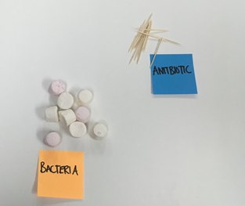
Image credit: Karen Dowers, WCAIR
- Explain that for the antibiotic to work it must break the surface of the bacteria. Can the participants pick up the bacteria with the antibiotic?
- Now add the hard-shelled sweets onto the table and label them.
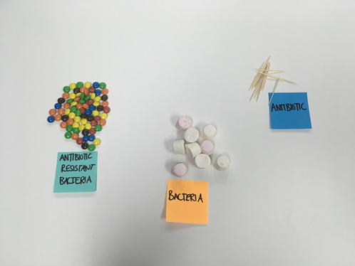
Image credit: Karen Dowers, WCAIR
- Now try to pick up the antibiotic resistant bacteria with the cocktail stick. It’s pretty tricky. What happens when you mix the resistant bacteria in with the normal ones?

TAKE IT FURTHER
Play BrainPOP movie Antibiotic Resistance game, available online: https://www.brainpop.com/games/antibioticresistancegame/
Scientists are trying to make new medicines to work against antibiotic resistant bacteria. Some of them work by different ways than older antibiotics. Can you think of a way of picking up the hard-shelled sweets?
Can you explain to the rest of your group what causes resistance? What can you do to help the problem?

