## modelling molecules

#### Aim of Activity

To build your own 3D chemical structures.

#### About the Activity

At the level we can see them, medicines look like tablets, pills or liquids. At a much smaller level, tinier than we can see, they have a much wider variety of shapes. They’re often so tiny that we have to use special lab equipment to know what they look like, but each type of medicine has its own shape. They can have rings, lines, all sorts of shapes. They work in 3 dimensions!

We can model what they look like. There are modelling kits that you can buy, but it’s also easy enough to do it with things you might find around the house. Fruit can be a surprisingly useful tool for science!

Every medicine you take is made up different atoms. They are joined together by chemical bonds, which are formed in chemical reactions. For every type of atom, rules apply as to how many chemical bonds it can form. These are the most common type of atoms in medicines:

|  |  |  |  |
| --- | --- | --- | --- |
| Atom name | Chemical symbol | Number of bonds | Common colour in model |
| Carbon | C | 4 bonds for each atom | Black |
| Nitrogen | N | 3 bonds for each atom | Red |
| Oxygen | O | 2 bonds for each atom | Blue |
| Hydrogen | H | 1 bond for each atom | White |

#### What you’ll need

* 4 different objects, 1 each for carbon, oxygen, nitrogen and hydrogen atoms. For example:
  + Fruit: white grapes, black grapes, blueberries, strawberry
  + Sweets: marshmallows, liquorice, gummy bears, cherries
  + Marshmallow: 4 different sizes / colours
* Cocktail sticks to attach everything together.

#### What to do

You might want to start by building some simple molecules that you may have heard of – water and carbon dioxide.

1. Hopefully, you already know what water is – it’s the clear, colourless liquid that we drink. A chemical formula helps scientists describe what makes a molecule. Water’s chemical formula is H2O, which means it has 2 atoms of hydrogen and one of oxygen.



1. Carbon dioxide is another chemical you may have heard of. It’s what gives fizzy drinks their bubbles. It’s also made when cars, lorries and other things burn fuels. Carbon dioxide has the formula CO2, which means it has 1 atom of C, or carbon, and 2 of O, or oxygen. Because carbon always has to have 4 bonds for each atom, and oxygen always has to have 2, it looks a bit more complicated than the water molecule.



1. Now that you’ve become an expert on chemical modelling, you can move onto more advanced chemicals…even medicines! Start from a carbon/white grape and attach a stick (or 2 if in the drawing there are 2 lines connecting 2 atoms). On the other side attach the next atom/fruit. Congratulations, you formed a chemical bond!

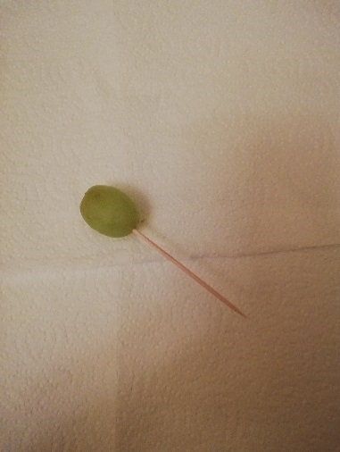

Image credit: Dr. Mattia Cocco, WCAIR

Now, add another atom and so on until you build the whole molecule. Watch out with the sticks because you can hurt other people if not used correctly.

You can find many, many different chemical molecules if you look on the internet. Here are a couple that you might have heard of:

* Ethanol:

* Ibuprofen:

Image credit: Dr. Mattia Cocco, WCAIR

These are just suggestions of what to use. They can be adapted to anything you have more available. Release your imagination and try to build molecules in most extravagant way!

#### Take it Further

What about inventing your own molecule? You can create any molecule you want – so long as you follow the rules about the number of bonds!