Medicine Maker
INFECTIOUS DISEASES OF THE WORLD
AIM OF ACTIVITY
To learn about what infectious diseases are and where they are found.
BACKGROUND INFORMATION
Infectious diseases are caused by tiny living things such as bacteria, viruses, fungi or parasites. We sometimes call living things “organisms”. Many of these organisms live in and on our bodies. They are usually harmless, but sometimes they may cause disease. They can be passed from person to person, by bites from insects or animals, or by ingesting contaminated food or water.

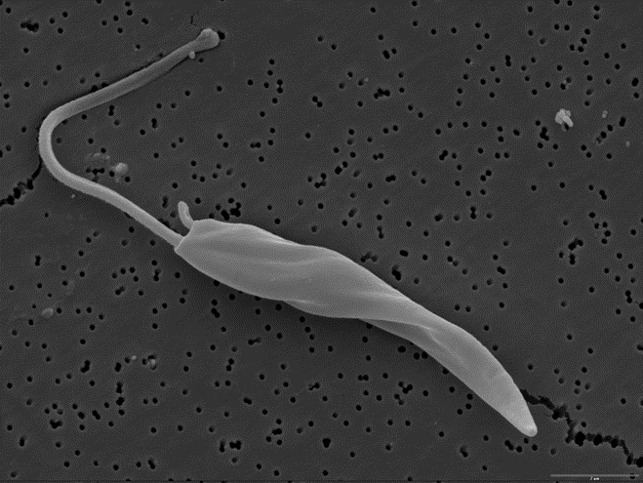
Image: electron microscope picture of a Leishmania parasite by Dr. Sujatha Manthri, WCAIR

Many infectious diseases, such as measles and chickenpox, can be prevented by vaccines. Frequent and thorough hand-washing also helps protect you from most infectious diseases.
Some diseases are more common in different parts of the world. During this section you will learn about different diseases. You can also discover where they are found, what medicines help, what these organisms look like and how they are spread.

ABOUT THE ACTIVITY
Infectious diseases are caused by tiny living things like bacteria, viruses and parasites. In this activity, a number of infectious diseases need to be placed onto a map to show where they are most common. Answers are found in the notes section.
WHAT YOU’LL NEED
- Outline of world map
- Disease names
- Pins
WHAT TO DO
- Begin with a discussion about where diseases are found in the world. What do you know about them to begin with?
- Place your list of diseases alongside your world map. Guess where each disease is most commonly found by placing the name next to the area of the map.
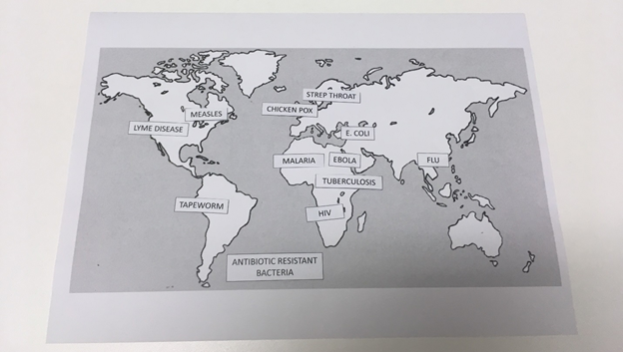
Image credit: Karen Dowers, WCAIR
- Discuss why those decisions were made, then check against our handy answer sheet. Were you right

TAKE IT FURTHER
Find out more about one disease and design a poster to tell others more about it.
Older children might also want to play with our app, This is Disease Lab. It’s available for free on Google Play Store and iTunes, and you can check out our website at wcair.dundee.ac.uk for links and more information. We think it’s the most infectious game in the world!

NOTES FOR LEADERS
There are lots of diseases around the world! These are a few of the most common. You can find out more information by looking at encyclopaedias, or on the internet. Do be careful with online information; it may be out of date, or it may simply be wrong! Sources like the NHS, the CDC in the United States and the World Health Organisation tend to be the most thorough and reliable.
Disease | Main area | Cause
Measles | Africa & Asia | Virus
Lyme disease | Europe & North America | Bacteria (Tick Bite)
Tapeworm | South America, Africa & Asia | Parasite
Chickenpox | Everywhere | Virus
Strep. throat | Everywhere | Bacteria
HIV | Africa | Virus
Flu | Asia | Virus
E. coli | Everywhere | Bacteria
Malaria | South America, Africa & Asia | Parasite (Mosquito)
Tuberculosis | South America, Africa & Asia | Bacteria
Antibiotic resistant bacteria | Everywhere | Bacteria
Ebola | Africa | Virus

You could do this activity all at once, or you could do it over a few weeks, gradually building up your own world map.

