Growing Microbes
AIM OF ACTIVITY
Participants will be able to observe growth of microbes and reflect on the importance of good hand hygiene.
INTRODUCTION
Microorganisms (microbes for short) come in a dazzling array of shapes and (small) sizes. Microbes include distantly related groups called archaea, bacteria, fungi, viruses, and protists.
Microbes can be found living in most places on Earth, including deep sea vents, volcanic soil, on and inside plant roots, stems and leaves, and in your intestines and on your skin.
Some microbes are good and help us with body systems like digesting our food. Other microbes can make us sick, causing illnesses and diseases.
Many microbes are too small to see without using a microscope. But when microbes have access to enough food, they can make more copies of themselves. Eventually the number of microbes increases, and the microbes form groups called “colonies” that are visible to the naked eye.
Agar is a firm jelly made from seaweed. It is used to set liquid food that the microbes can eat. In the laboratory scientists place microbes on agar plates and incubate the samples (keep them warm) to let the microbes grow.
The image on the left is a drawing of an individual microbe cell, a cellular parasite called Leishmania. The parasite is around 0.005mm long. (image credit Sujatha Manthri, University of Dundee) The image on the right shows lots of microbe colonies. They are on an agar plate, which is around 15cm wide (image credit: Erin Hardee, University of Dundee)
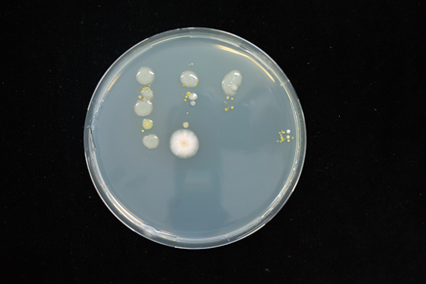

We can watch microbes grow over time by doing the following simple experiment:
SAFETY – In this experiment you will grow microbes on bread. It is important that you do not open the bags once you have sealed them. Simply place the sealed bags in a waste bin.

ACTIVITY – WHITE BREAD MOULD EXPERIMENT
WHAT YOU’LL NEED:
- 5 slices of white bread. The bread needs to be either homemade or not have any preservative.
- Sterile water – freshly opened bottled water should work. Put a few drops on each bread slice as they go into bags, without touching the bread with your hands.
- 5 new sandwich bags
- Clean kitchen tongs or a rubber glove
- Soap and water
- Hand sanitizer
- Pen and post-it notes or sticky labels
STEP 1 – Place one slice of bread in a clean sandwich bag. Try to make as little contact with the bread as possible. Label the bag ‘no contact’.
STEP 2 – Before washing your hands, place another slice of bread inside another plastic bag. Feel free to touch the bread all over before adding it to the bag! Write ‘unwashed hands’ on a label and stick it on the bag.
STEP 3 – Participants should now wash their hands thoroughly with soap and water.
STEP 4 – With your freshly washed hands, place the third slice of bread in the plastic bag. Feel free to touch the bread all over before adding it to the bag! Note down ‘washed hands’ on a label and stick the post-it on the bag.
STEP 5 – Apply some hand sanitizer. Place another slice of bread in a sandwich bag. Feel free to touch the bread all over before adding it to the bag! Note ‘sanitizer’ on a label and stick it on the bag.
STEP 6 – Rub the slice of bread over a surface that isn’t be cleaned often e.g.: a laptop, a tabletop, a door handle, an iPad or a phone. Now place the last slice of bread in the sandwich bag. Label this bag ‘surfaces’. Wash your hands again.
You will end up with bags of bread a bit like this:
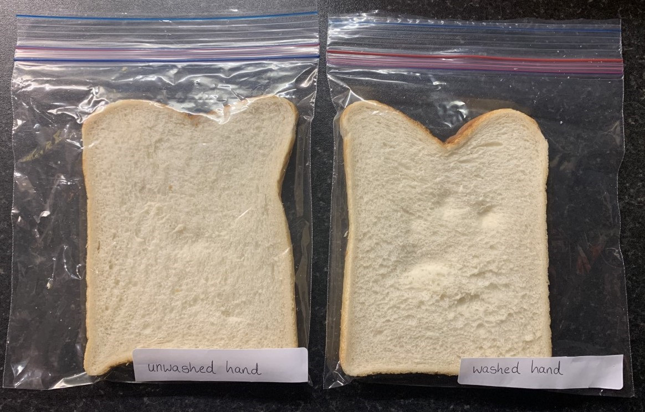STEP 7 - Place the bags somewhere warm. If you have an airing cupboard that is ideal.
STEP 8 - Set your predictions. What do you think each slice of bread will look like in a few days? Why?
STEP 9 - After a few days, you’ll be able to watch the microbial growth and the difference between all the slices of bread! Have a look at the different bags and discuss the differences you can see. Why do you think they are so different?
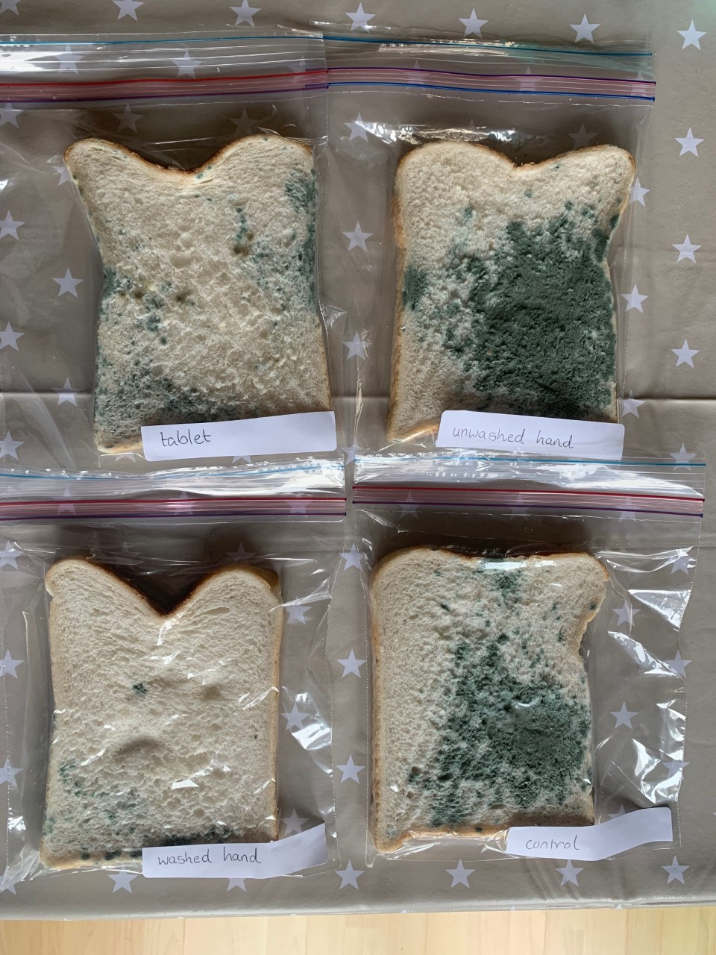
The no contact bread sample may only have one or two colonies on it. This is because it might have picked up some microbes as we moved it through the air into the bag. Even when we wash our hands, we can leave some microbes behind. And we all have items that we forget to clean – computer keyboards, keys, our phones? What items do you forget to clean?

CONCLUSION
Microbes are everywhere. We often need a microscope to see them, but we can see the growth of microbes over a time and we can also see the direct effect that washing our hands to reduce the number on our skin.

THOUGHT QUESTION:
What would the microbes on our hands be like if we never washed them?
FUN FACT
Alexander Fleming was a Scottish scientist. In 1928, he went away for his summer holidays without cleaning his lab. When he came back, his plates were covered with mould – this is a type of microbes called a fungus! He was going to throw the plates away, but then realised something important. Around the mould, the bacteria that were also on the agar plate had been killed. From this observation, the first antibiotics were eventually created. You can see one of Fleming’s plates at the National Museum of Scotland either in person or online, at https://www.nms.ac.uk/explore-our-collections/collection-search-results/?item_id=649943

