Medicine Maker
BUILD A BIOFILM
AIM OF THE ACTIVITY
To consider biofilms and the role they play in diseases.
ABOUT THE ACTIVITY
Biofilms are communities of microbes that live on a variety of both natural and manmade surfaces. You have probably encountered biofilms before – the dental plaque that forms on your teeth and causes cavities is an example of one. So is the film that you scrub off your toilet bowl!
We sometimes call biofilms ‘bacterial cities’ because it’s a good illustration of what a biofilm is – lots of different types of bacteria and other microbes growing together on a surface. They cooperate and even communicate with one another in order to maximise their chances of survival.
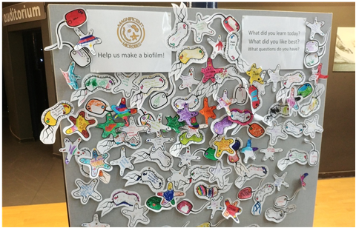
Image credit: Ali Floyd, WCAIR

Biofilms give bacteria protection from outside elements. A biofilm forms when bacteria attach to a surface and then produce a sticky, sugary matrix known as "extracellular polymeric substances", or EPS. The EPS surrounds the bacteria and allows them to form three-dimensional colonies which are protected against things that would otherwise kill them, like antibiotics. It has been shown that biofilms are resistant to doses of antibiotics over 1000 times stronger than those needed to kill free-floating bacteria! They also make it harder to remove the colonies with physical force, like with a toothbrush or toilet brush.
There are several different ways you can model biofilms. We have lots of ideas on our website: http://www.lifesci.dundee.ac.uk/sites/www.lifesci.dundee.ac.uk/files/Biofilms_teacher_guide.pdf One of the easiest and most fun for large groups is with paper cut-outs.

WHAT YOU’LL NEED
- shapes templates at the bottom of this document
- colouring pens and pencils
- blu-tac or other way of sticking them up
- a wall or poster board to make your biofilm on

WHAT TO DO
- Cut out the bacterial shapes from the template, either with the participants present or in advance
- Colour in the bacteria, or write a message on them. If you have a fun fact, or a science question, it can be a great way of getting the children to share them
- Stick the bacteria up on a wall or other surface.

TAKE IT FURTHER

You can find out lots more about bacteria and other microbes with these handy links:
https://discovery.dundee.ac.uk/en/publications/images-of-microbiology-activity-book
https://discovery.dundee.ac.uk/en/publications/images-of-microbiology
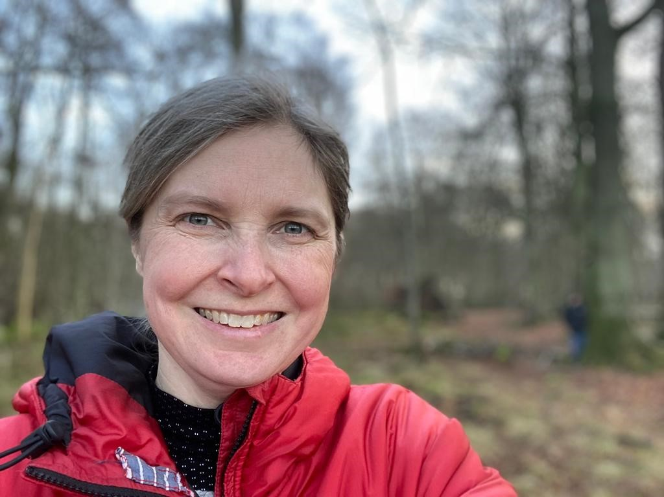
MEET THE SCIENTIST
Nicola Stanley-Wall is Professor of Microbiology at the University of Dundee. Her research focuses on biofilms, using a bacterium called Bacillus subtilis. With the lab that she leads, her work helps us to understand how bacteria live and work, and might even help us to make better ice cream!

Bacteria Templates