Medicine Maker
BUILD A BODY
AIM OF ACTIVITY
To identify where organs are in the body and learn which organs some diseases target.
ABOUT THE ACTIVITY
Before designing a new medicine it is important that we understand the body, as different treatments need to reach different organs. For example, medicines that treat TB need to target the lungs while medicines that treat malaria need to target the liver and/or the blood.
WHAT YOU’LL NEED
- Paper large enough to draw around a participant
- A pen
- The organs, the diseases and the “how it is transmitted” cards printed out from the resources found at the end of this document.
- Blue-tac, tape or sticky Velcro tabs.
WHAT TO DO
- In small groups, choose a participant to draw around onto the paper.
- Let the group guess where to put the organs (please refer to the supporting image below as to where the organs should go).
- Once the group have the correct location for all the organs, they can play our game to learn which diseases affect which organs and how these diseases are spread.
- Give each group a disease and a copy of the “how it is transmitted” cards, you’ll find these at the end of this document.
- The group should guess the correct target organ and transmission method. Once they have the correct combination, let them try a different disease.
- All answers can be found in the table below.

Disease | Organ | Transmission
Tuberculosis | Lung | Inhalation
Malaria | Liver/blood | Insect bite
Cryptosporidiosis | Intestine | Contaminated food or water
Dengue fever | Blood | Insect bite
Sleeping sickness | Brain/blood | Insect bite
Chagas’ disease | Heart/blood | Insect bite
Helicobacter pylori | Stomach | Contaminated food or water

TAKE IT TO THE NEXT LEVEL
Once you’ve added the organs, can you add other systems to the body? You might want to add bones, or even the circulatory system if you’re feeling brave!
NOTE FOR LEADER
We’d recommend that younger children do parts 1 and 2 and learn where the organs are found in the body. Older children should complete the whole activity.
There are several great sources online for information about anatomy. We’ve provided a diagram here, but feel free to explore yourself. 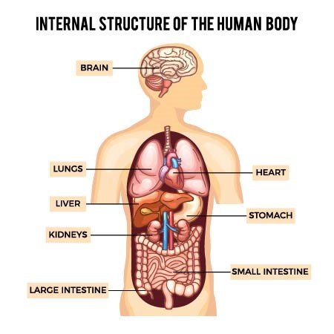

Organs. Print these and cut them out to place on your body template: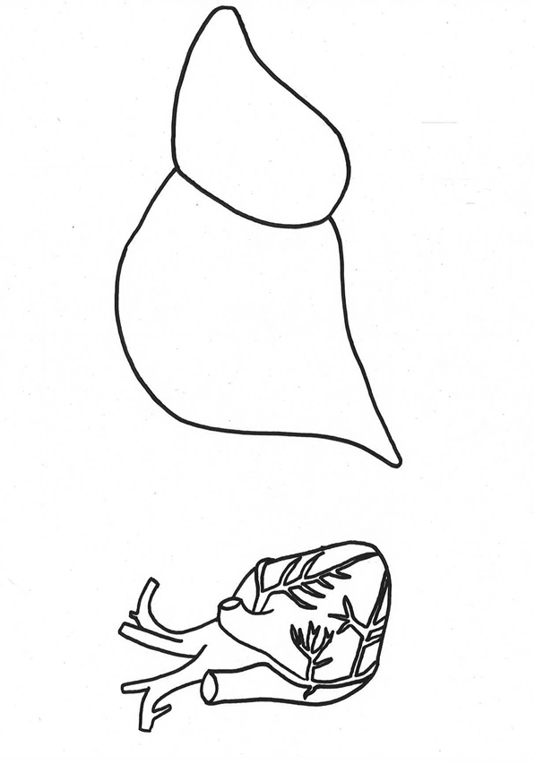

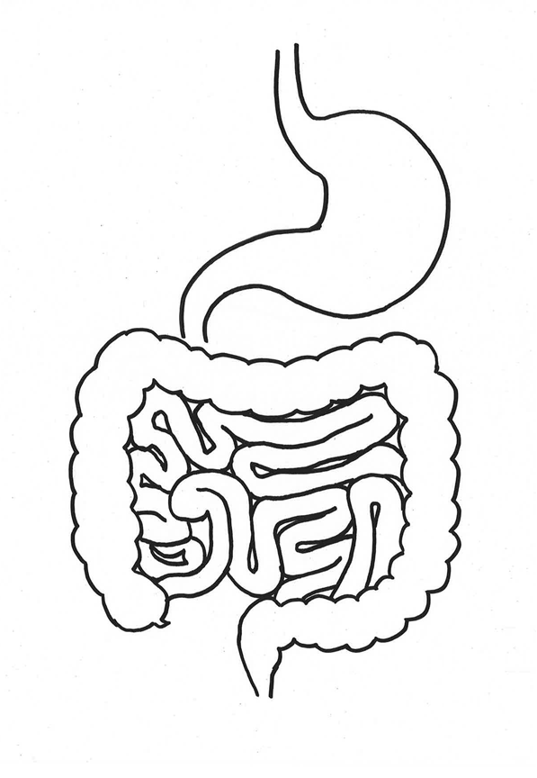

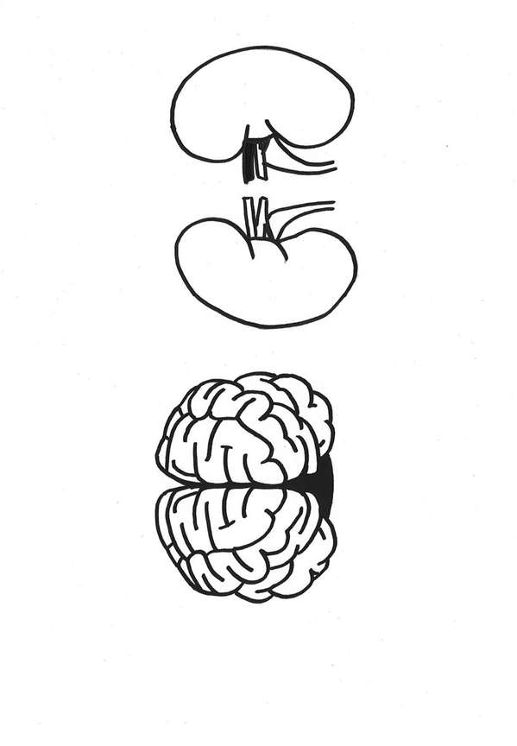
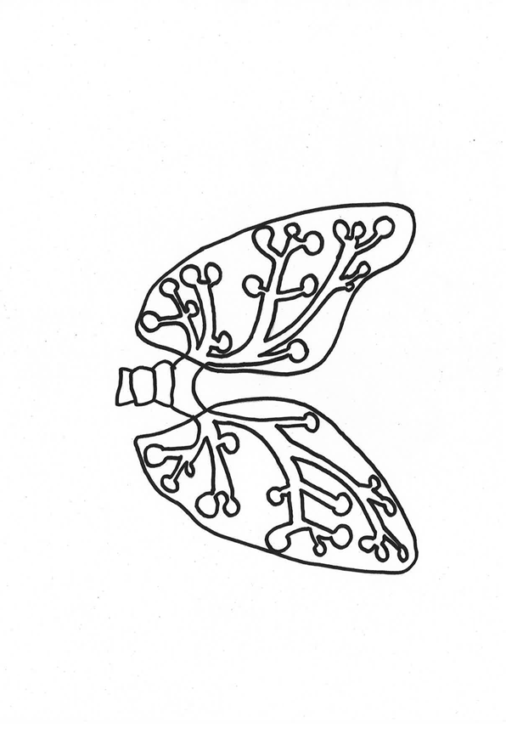

Diseases – Print these and cut them out.
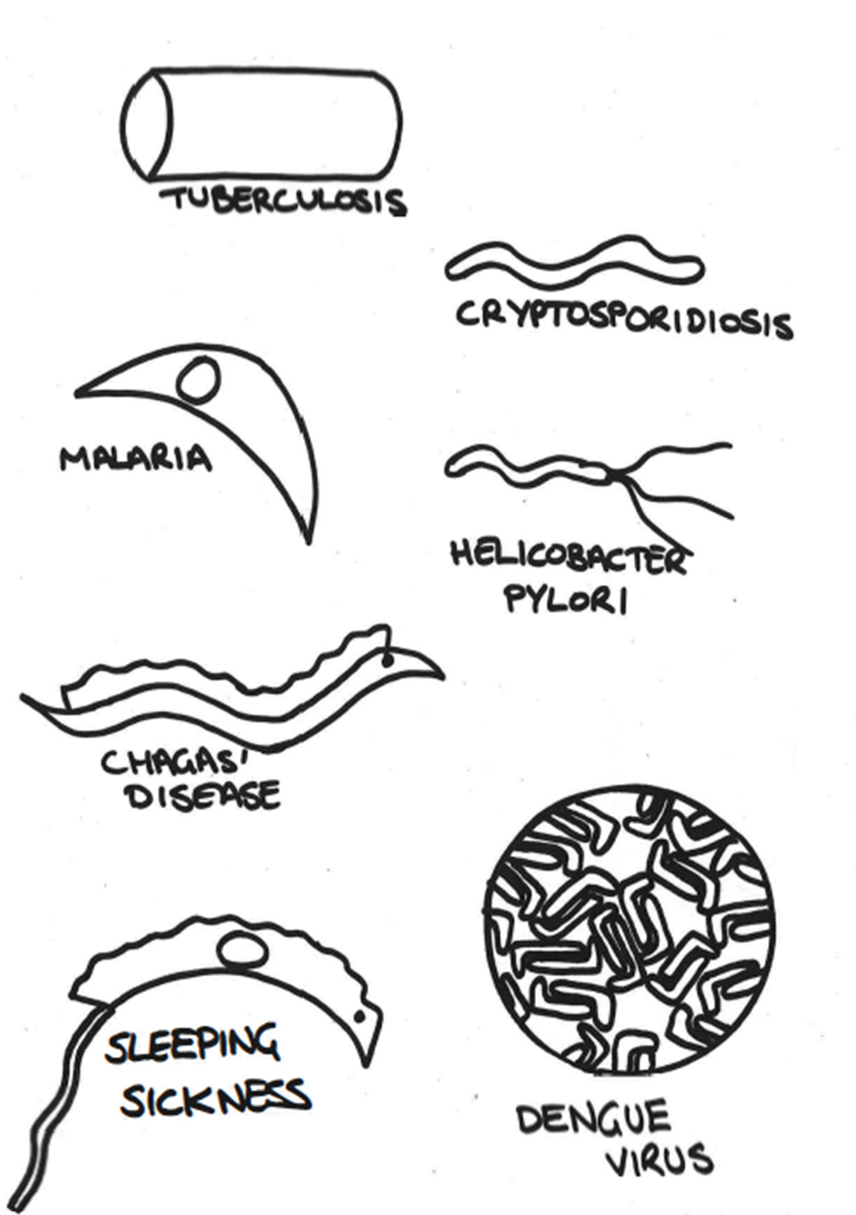

How it is transmitted cards – Print these and cut them out.
